NOME:………………………..; COGNOME:……….……………………; CLASSE:…….; DATA:…../…../…….;
VERIFICA SCIENZE

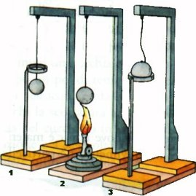
1) DESCRIVI L’ESPERIMENTO CHE VEDI QUI A LATO.
______________________________________________________________
______________________________________________________________
______________________________________________________________
______________________________________________________________
______________________________________________________________
______________________________________________________________
________________________________________________________________________________
________________________________________________________________________________

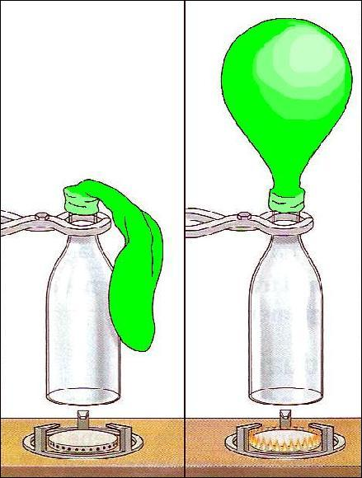
2) DESCRIVI L’ESPERIMENTO CHE VEDI QUI A LATO.
______________________________________________________________
______________________________________________________________
______________________________________________________________
______________________________________________________________
______________________________________________________________
______________________________________________________________
________________________________________________________________________________
________________________________________________________________________________

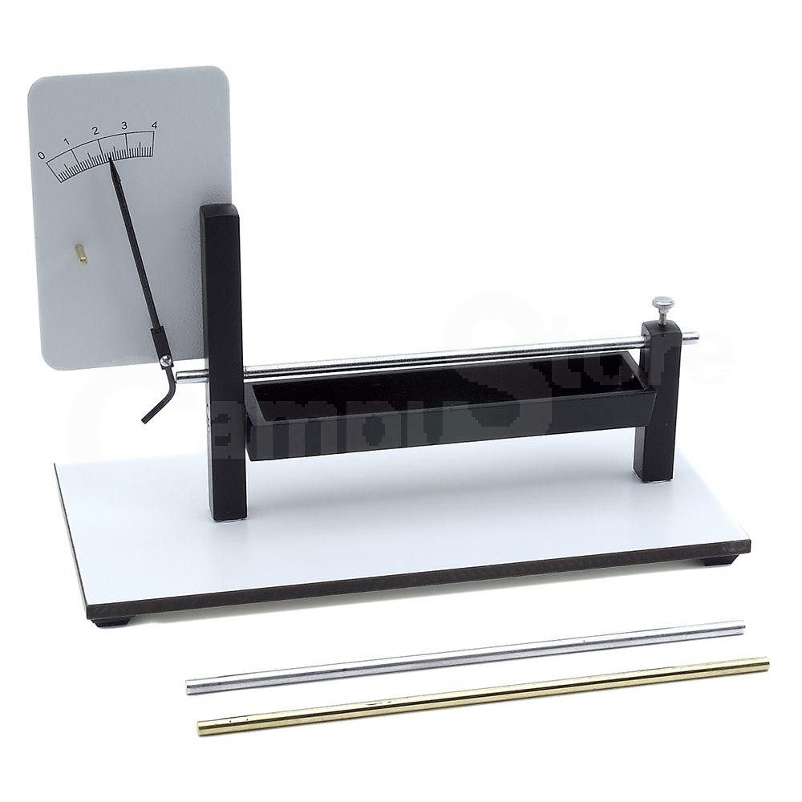
3) DESCRIVI L’ESPERIMENTO CHE VEDI QUI A LATO.
PRIMA
UN’ASTA DI METALLO (CONTINUA TU)______________________________
______________________________________________________________
______________________________________________________________
______________________________________________________________
______________________________________________________________
______________________________________________________________
DOPO
______________________________________________________________
______________________________________________________________
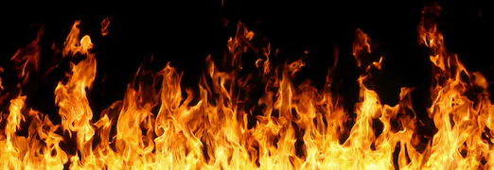
______________________________________________________________
______________________________________________________________
______________________________________________________________

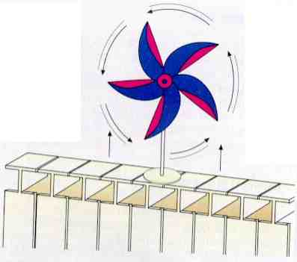
4) DESCRIVI L’ESPERIMENTO CHE VEDI QUI A LATO.
SE METTO UNA GIRANDOLA POSTA SOPRA AD UN CALORIFERO CALDO (CONTINUA TU)____________________________________________
______________________________________________________________
______________________________________________________________
______________________________________________________________
______________________________________________________________
________________________________________________________________________________
________________________________________________________________________________
________________________________________________________________________________

5) CHE COSA SI INTENDE PER AGITAZIONE TERMICA?
________________________________________________________________________________________________________________________________________________________________________________________________________________________________________________________________________________________________________________________________________________________________________________________________________________________________________________________________________________________________

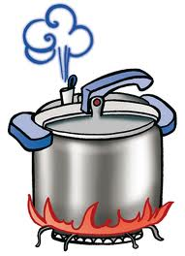
6) CON QUALE STRUMENTO SI MISURA LA TEMPERATURA? _______________________
_____________________________.QUALE È L’UNITÀ DI MISURA DELLA TEMPERATURA NEL SISTEMA INTERNAZIONALE ? SCRIVI COME SI CHIAMA E IL SIMBOLO. _________
_______________________________________________________________________________ QUALE È L’UNITÀ DI MISURA DELLA TEMPERATURA NEI TERMOMETRI? SCRIVI COME SI CHIAMA E IL SIMBOLO.________________________________________________

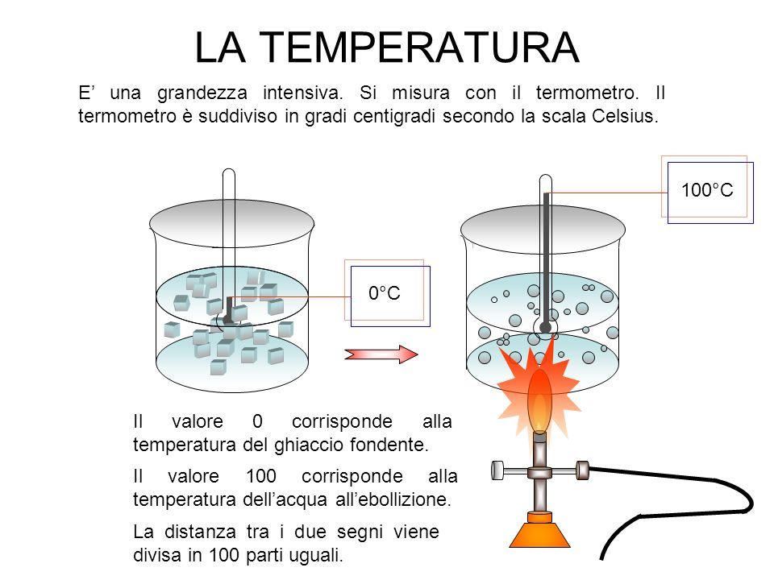
7) DESCRIVI COSA RAPPRESENTA L’IMMAGINE QUI A FIANCO.
_____________________________________________________________________________ _____________________________________________________________________________ _____________________________________________________________________________ _____________________________________________________________________________
°C
_____________________________________________________________________________
_____________________________________________________________________________
_____________________________________________________________________________
QUALE PASSAGGIO DI STATO STA ACCADENDO ALL’ELEMENTO ACQUA? ________________________________________________________________________________________________________________________
________________________________________________________________________________________________________________________
A QUALE TEMPERATURA AVVIENE IL PASSAGGIO DI STATO?__________________________

8) DESCRIVI COSA RAPPRESENTA L’IMMAGINE QUI A FIANCO.
°C
___________________________________________________________________________________
___________________________________________________________________________________
___________________________________________________________________________________
___________________________________________________________________________________
___________________________________________________________________________________
___________________________________________________________________________________
QUALE PASSAGGIO DI STATO STA ACCADENDO ALL’ELEMENTO ACQUA? _____________________________________________________________________________________________
_______________________________________________________________________________________________________________________
A QUALE TEMPERATURA AVVIENE IL PASSAGGIO DI STATO?____________________________

9) LA TEMPERATURA DI EBOLLIZIONE DELL’ACQUA DIPENDE DALLA PRESSIONE ATMOSFERICA?
______; SPIEGA IL PERCHÉ, FACENDO DEGLI ESEMPI SAPENDO CHE AL MARE LA PRESSIONE È DI 1 atm (ATMOSFERA) E IN MONTAGNA AD UN’ALTEZZA DI 2000 m (METRI) LA PRESSIONE È DI 0,78 atm.
________________________________________________________________________________
________________________________________________________________________________
________________________________________________________________________________
________________________________________________________________________________
________________________________________________________________________________
________________________________________________________________________________
________________________________________________________________________________
________________________________________________________________________________
________________________________________________________________________________

10) DESCRIVI COSA È LA PENTOLA A PRESSIONE E A CHE COSA SERVE.
_____________________________________________________________________
_____________________________________________________________________
_____________________________________________________________________
_____________________________________________________________________
_____________________________________________________________________
_____________________________________________________________________
________________________________________________________________________________
________________________________________________________________________________
________________________________________________________________________________

PUNTEGGIO:__________; VOTO:_______;

