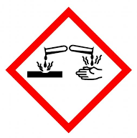
NOME: ……………………… COGNOME: ………………………. CLASSE: 2….; DATA…………;

VERIFICA DI SCIENZE

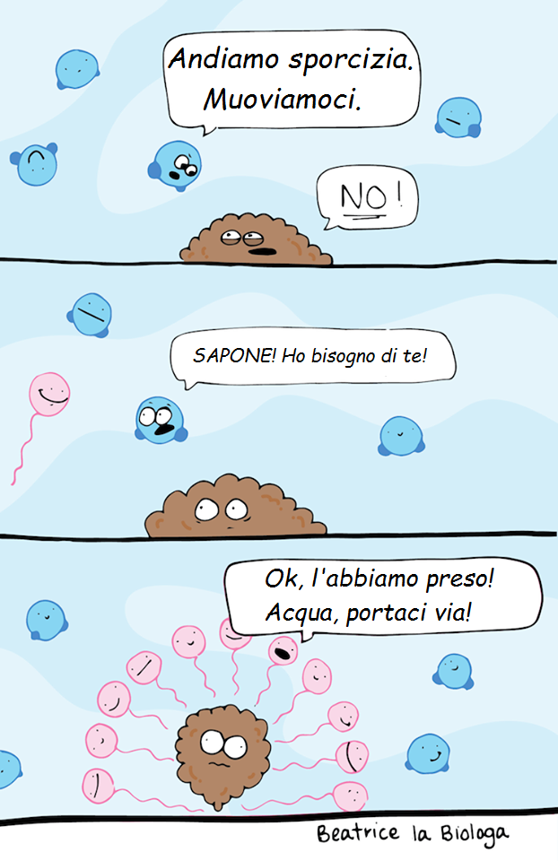
1) COME FUNZIONA IL SAPONE? GUARDA IL FUMETTO QUI DI FIANCO. QUALE MOLECOLA DICE << ANDIAMO SPORCIZIA.MUOVIAMOCI .>> ?________________ CHI RISPONDE << NO!>>? ________________________LA FIGURA CHE SEMBRA UN PALLONCINO APPESO AD UN FILO CHE MOLECOLA RAPPRESENTA?______________________________SPIEGA COSA VUOLE SPIEGARCI QUESTO FUMETTO: ______________________________________________________
_____________________________________________________________
_____________________________________________________________
_____________________________________________________________
_____________________________________________________________
_____________________________________________________________
_____________________________________________________________
_____________________________________________________________
_____________________________________________________________
_____________________________________________________________

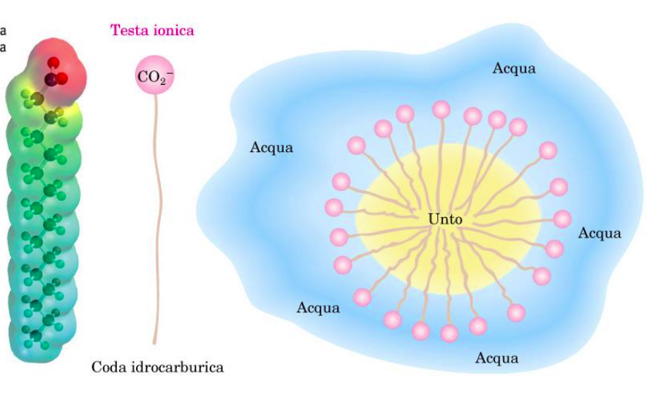
2) QUALE È ESATTAMENTE IL MECCANISMO CON CUI FUNZIONA IL SAPONE? GUARDANDO L’IMMAGINE QUI A FIANCO DAI UNA SPIEGAZIONE SAPENDO CHE L’UNTO (SPORCO) È È APOLARE, L’ACQUA È POLARE E LA MOLECOLA DI SAPONE HA UNA CARICA ELETTRICA IN TESTA E UNA CODA APOLARE.___________________________________
_____________________________________________
_____________________________________________
-_____________________________________________
_____________________________________________
_____________________________________________
________________________________________________________________________________________ ________________________________________________________________________________________
________________________________________________________________________________________

3) SPIEGA COME SI FORMA IL SAPONE , METTI UN ASTERISCO SUI REAGENTI E UN PALLINO SUI PRODOTTI. METTI NEI RIQUADRI LE PAROLE CORRETTE:
SODA CAUSTICA(NaOH= IDROSSIDO DI SODIO) / ACQUA / ACIDO GRASSO / SAPONE
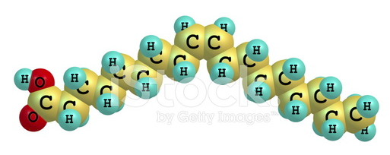
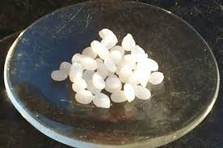
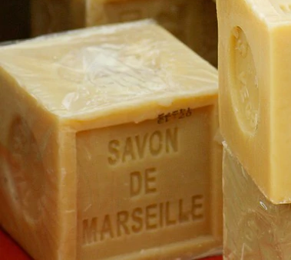
+
+ H2O

4) IL SIBOLO CORROSIVO SI TROVA SULLA CONFEZIONE DI UNO SOLO DEI REAGENTI CHIMICI DELLA REAZIONE QUI SOPRA. DI QUALE REAGENTE SI TRATTA?______________________________. DA CHE COSA DIPENDE LA SUA PERICOLOSITÀ?____________________________________________________________________________
________________________________________________________________________________________
________________________________________________________________________________________
________________________________________________________________________________________________________________________________________________________________________________________________________________________________________________________________________________________________________________________________________________________________
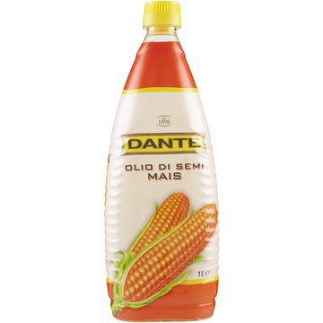
5) LA MISCELA DI ACIDI GRASSI CHE ABBIAMO USATO IN LABORATORIO DA QUALE PRODOTTO PROVENIVA?_________________________________DESCRIVI IL PROCEDIMENTO PER OTTENERE IL SAPONE:____________________________________________________________________
__________________________________________________________________________
___________________________________________________________________________
________________________________________________________________________________________
________________________________________________________________________________________
________________________________________________________________________________________
________________________________________________________________________________________

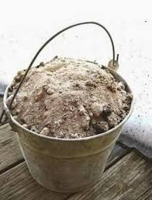
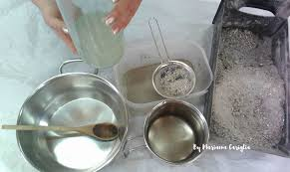
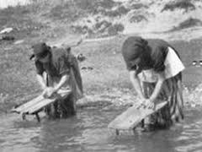
6) CHE COSA È LA LISCIVA? SPIEGA COME
SI OTTIENE E A CHE COSA SERVIVA.___________
______________________________________
______________________________________
______________________________________
________________________________________________________________________________________________________________________________________________________________________________

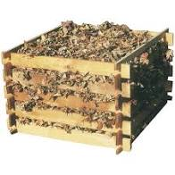
7) CHE COSA È LA COMPOSTIERA E A CHE COSA SERVE?_________________________________
_________________________________________________________________________
_________________________________________________________________________
_________________________________________________________________________
_________________________________________________________________________
________________________________________________________________________________________

8) QUALE MATERIALE ORGANICO SI RIESCE A DECOMPORRE IN NATURA E CHI LO DECOMPONE?________________
________________________________________________________________________________________
________________________________________________________________________________________________________________________________________________________________________________________________________________________________________________________________________________________________________________________________________________________________________________________________________________________________________________________

9) COSA È E A COSA SERVE UNA CARTINA TORNASOLE ?______________________________________________
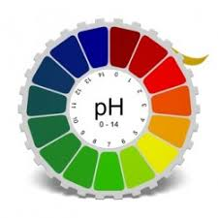
________________________________________________________________________________________
________________________________________________________________________________________________________________________________________________________________________________________________________________________________________________________________________________________________________________________________________________________________________________________________________________________________________________________

10) COSA È E COSA STUDIA LA CHIMICA ORGANICA ?________________________________________________
________________________________________________________________________________________
________________________________________________________________________________________________________________________________________________________________________________________________________________________________________________________________________________________________________________________________________________________________________________________________________________________________________________________

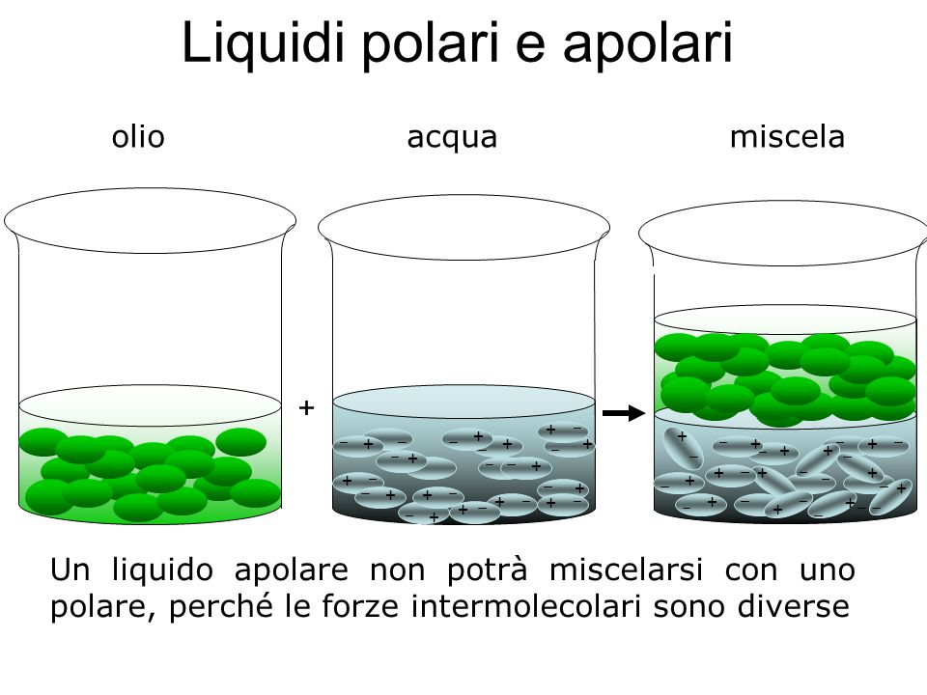
11) COSA VUOL DIRE SIMILE SCIOGLIE IL SUO SIMILE ?______________________________________________
________________________________________________________________________________________
________________________________________________________________________________________________________________________________________________________________________________________________________________________________________________________________________________________________________________________________________________________________________________________________________________________________________________________________________________________________________________________________________________

